**Exercise – 6.2**

Use **MATLAB (Simulink)** to

1. simulate a three-phase controlled full wave rectifier supplying an R-L-E load for a given firing angle

Use **MATLAB Code** to

1. plot the variation of output voltage with respect to firing angle variation

**Initial Calculations**:

To construct the **6-pulse generator**:

* Phase delay (secs) in firing the thyristors of a three phase rectifier:

**T1**🡪 (30+alpha)*10e-3/180

**T2**🡪 (90+alpha)*10e-3/180

**T3**🡪 (150+alpha)*10e-3/180

**T4**🡪 (210+alpha)*10e-3/180

**T5** 🡪 (270+alpha)*10e-3/180

**T6**🡪 (330+alpha)*10e-3/180

* Time period of pulses = 20 ms
* Pulse width (% of period) = 2 %

**Simulink Circuit**:

1. **Three-phase controlled full wave rectifier**

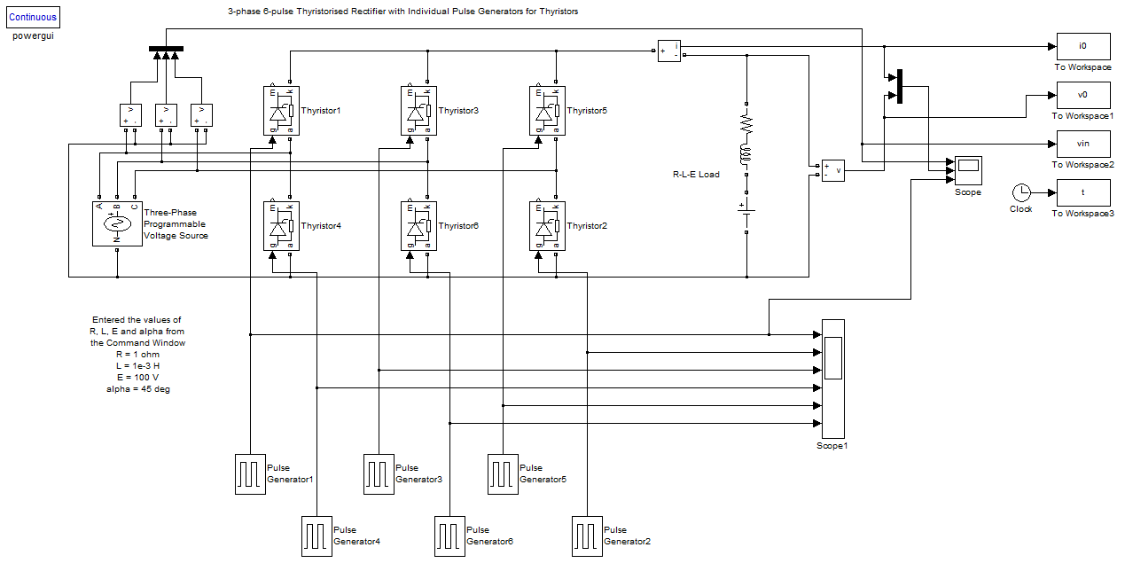

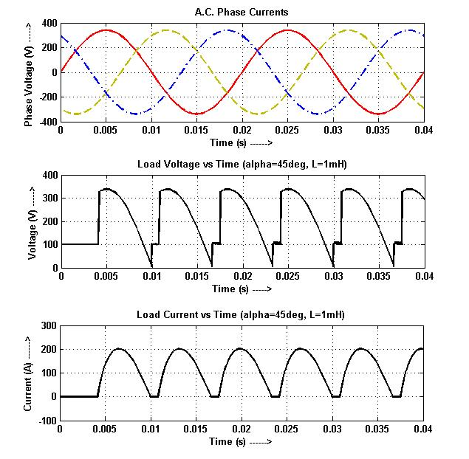**Waveforms:**

1. **Discontinuous Conduction Mode** **(alpha=45°, L=1 mH)**
2. **Continuous Conduction Mode (alpha=60°, L=10 mH)**

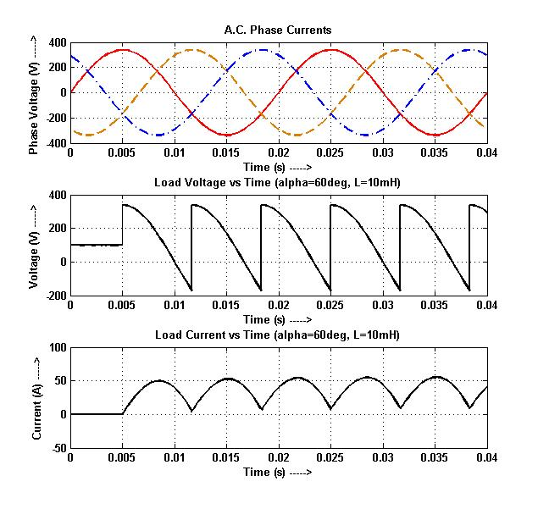

**Formulae:**

$$V_{0}=\frac{3\sqrt{3}V_{m}}{π}\cos\left(α\right)$$

**m-code:**

% Ex-6.2 (Power Electronics)

% Sambhav R Jain

% 107108103

clc;

clear all;

close all;

V = input('Enter the rms phase voltage: ');

Vm = V*sqrt(2);

alpha=0:0.01:180;

Vo=3*sqrt(3)*Vm/pi*cosd(alpha);

plot(alpha,Vo)

grid on

xlabel('Firing Angle (deg) ------>');

ylabel('Output Voltage (V) ------>');

title('Output voltage vs firing angle');

**Plot:**

(Phase Voltage rms, V=239.6 V)

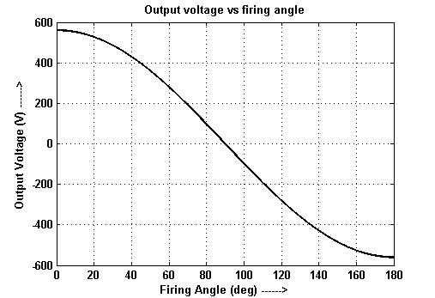

**Results:**

Hence the circuit of a three-phase controlled full wave rectifier supplying an R-L-E load is simulated using MATLAB-Simulink and the necessary waveforms are plotted for particular firing angles. Also, the variation of output voltage with varying firing angles is plotted with the help of MATLAB-Code.